Daily Schedule
7:30 - 7:55 |  Breakfast
7:55 - 8:10 |  Morning Message
8:10 – 9:30 |  Math
9:30- 10:50  10:00- 11:00 |  Reading/ELA  Workforce training on Tuesdays and Thursdays
10:50-11:45 |  Science/ Life science/ Social (IEP goals will be continued individually, in rotation).
11:50-12:50 |  Lunch
12:50-1:50 | 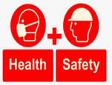 Health/ Safety/ Ind. Liv
1:50-2:30 |  P.E
2:30 – 3:15 |   Social/ Financial Management/ Economics / Personal Finance.  Vocational Activities (Individually in rotation).

